I copy past the mobile number in the correct field of the resource:
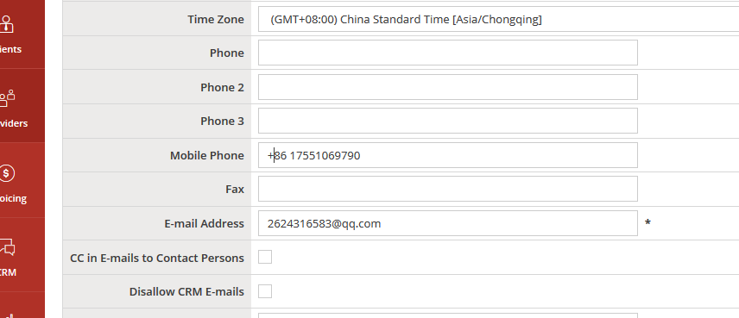

I click on save
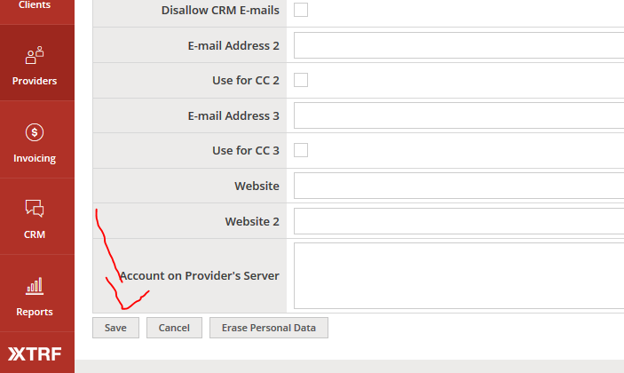
XTRF says:
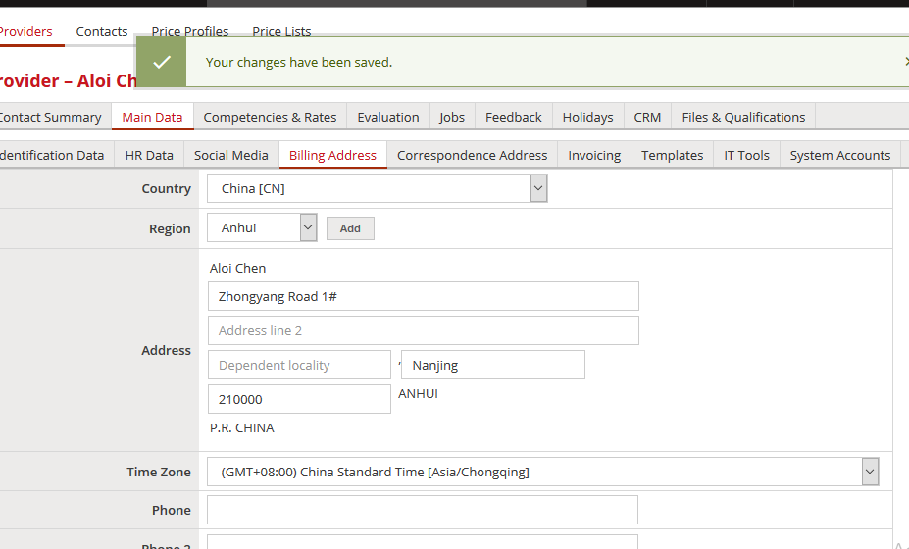

However, the mobile number is gone and I have to do it again:
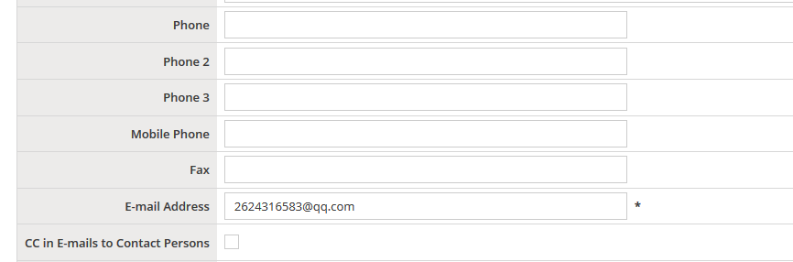

In this case, I had to copy past it 3 times before it saved correctly.

